UNIVERSITE DE RENNES

UFR Sciences de la Vie et de l'Environnement

Master de biologie, écologie et évolution

Parcours modélisation en écologie

Internship report

----------------------------------------------------------------------------

**Predicting earthworm diversity and distribution:**

**A comparative approach at national scale using multiple modeling algorithms**

**---------------------------------------------------------------------**

Abdourahmane DIALLO

*Presented on june 19, 2024, in Rennes*

*Academic year 2023 – 2024*

|  |  |
| --- | --- |
| Host institutions:  UMRS 6553 ECOBIO, Univ.Rennes - CNRS  UMR 1347 Agroécologie (INRAE de Dijon) | University supervisor:  Mrs. Marie-Pierre Etienne |
| Internship supervisors:  Mr. Daniel Cluzeau  Mr. Kevin Hoeffner  Mr. Walid Horrigue | Program coordinators:  Mr. Cédrick Wolf  Mr. Frederic Hamelin  Mrs. Marie-Pierre Etienne |

Internship from january 01 to june 30, 2024

# Acknowledgements

I would like to thank my three internship supervisors, Mr. Daniel Cluzeau, Mr. Kevin Hoeffner, and Mr. Walid Horrigue, for the time you took to mentor me, and for your invaluable advice and feedback.

I would also like to extend my gratitude to all my colleagues in the EcoBioSol team at UMRS 6553 ECOBIO, Univ.Rennes – CNRS and the BIOCOM team at UMR 1347 Agroécologie (INRAE de Dijon) for their kindness and good spirits.

I am grateful to all my classmates for their insightful discussions.

Special thanks to my friend Mamadou Saidou Diallo and to my family for their encouragement and attention to my work.

**Table of Contents**

Acknowledgements ii

1 Introduction 1

2 Materials and methods 3

2.1 Earthworm and land use data collections 3

2.2 Environmental data collection 5

2.3 Modeling strategy 6

2.3.1 ODMAP protocol 6

2.3.2 Variable selection, importance and effects 7

2.3.3 Model fitting and calibration 9

2.3.4 Model evaluation and selection 11

2.3.5 Predictions, interpolation and mapping of earthworm communities 12

3 Results 13

3.1 Model performance 13

3.2 Importance of the environmental variables 14

3.3 Effects of the environmental variables on earthworm communities 15

3.4 Spatial distribution of earthworms at the scale of France 16

4 Discussion 19

4.1 Improved performance of ensemble methods when predicting earthworm communities 19

4.2 Importance and effects of environmental variables 20

4.3 Limitations and considerations in earthworm distribution modeling 23

Conclusion 24

References i

# Introduction

Soil fauna provides a wide range of ecosystem services (Bardgett and Van der Putten, 2014; FAO, 2020), and among them, earthworms are referred to as "ecosystem engineers" (Jones et al., 1994) as they act on other soil organisms by modifying soil properties (Blouin et al., 2013): they contribute to soil structure development (Lavelle et al., 1997; Sharma et al., 2017; Edwards and Arancon, 2022), water infiltration and water retention through burrows and casts deposited in the soil (Capowiez et al., 2014; Cunha et al., 2016), organic matter dynamic and nutrient mineralization through the degradation of organic matter (Van Groenigen et al., 2019). In agroecosystems, for example, earthworms strongly affect crop yield, plant growth and other plant traits (Van Groenigen et al., 2014; Cunha et al., 2016). In addition, other studies have also shown that the imbalance in earthworm community composition reduces soil ecosystem services (Cardinale et al., 2012; Hooper et al., 2012; Van Groenigen et al., 2014).

The effects of environmental factors on earthworm communities have already been studied at the local scale (i.e. plot, Pelosi et al., 2014; Marchán et al., 2015; Gabriac et al., 2022) and at the regional scales (Marchán et al., 2016, 2021; Marchán and Domínguez, 2022; Diallo et al., 2023). However, the effects of environmental factors at the national scale are still poorly understood (Fourcade and Vercauteren, 2022; Salako et al., 2023). This finding, is probably due to limited data availability in the country, taxonomic inconsistencies and difficulties in merging existing databases (Rutgers et al., 2016). The first study conducted at a continental scale was carried out by Rutgers et al. (2016), who mapped the earthworm community using 3,838 sampled sites across 8 European countries. They observed that earthworm abundance and richness were affected by land use, soil properties (pH, organic matter, and texture), and latitude. Phillips et al. (2019) using 6 928 observations across 57 countries demonstrated that at a global scale, climatic factors (temperature and precipitation) were the most important environmental factors in shaping earthworm communities than soil properties (pH, organic carbon, texture, and Cation exchange capacity) or habitat cover. However, these studies employed a single modeling framework for predicting spatial distributions: generalized linear models (GLM) for Rutgers et al. (2016) and generalized linear mixed models (GLMM) for Phillips et al. (2019). Indeed, several studies have shown that the results can vary considerably depending on the type of predictive model used (Elith et al., 2006; Elith and Graham, 2009; Oppel et al., 2012; Li and Wang, 2013; Salako et al., 2023). Therefore, comparing different predictive models appears to be a crucial step in ensuring the quality of predictions (Oppel et al., 2012; Salako et al., 2023).

In recent years, a powerful tool for understanding biodiversity, its distribution and the potential drivers of this distribution has been the development of species distribution models (SDMs; Oppel et al., 2012; Salako et al., 2023). SDMs statistically model species or community’s correlations with environmental parameters (Elith and Leathwick, 2009; Guisan et al., 2017). However, this type of model requires, on the one hand, data on parameters characterizing communities and, on the other hand, spatial environmental data. Various SDMs exist, each with its advantages and disadvantages (Li and Wang, 2013; Valavi et al., 2021). Therefore, the main aim of this study was to select the best modeling algorithms to predict the earthworm community composition and distribution in France. Specifically, we sought to: (i) quantify and rank the influence of environmental factors (land use, soil properties, location, and climate data) on total abundance (individuals per m²), total biomass (g per m²), and total taxonomic richness of earthworms (number of taxa in the plot) in France (excluding Corse), and (ii) to build predicting map using these same earthworm parameters but based on environmental factors. To address these objectives, we selected five SDM modeling algorithms and compared their predictive performance. The selected algorithms were generalized linear models (GLM), generalized additive models (GAM), random forests (RF), generalized boosted regression models (GBM), and artificial neural networks (ANN). These algorithms were chosen based on their classification as regression algorithms (GLM and GAM) and machine learning algorithms (RF, GBM, and ANN), as well as their widespread use in recent studies (Li and Wang, 2013; Rutgers et al., 2016; Valavi et al., 2021; Salako et al., 2023). This comparative approach reduces uncertainty and identifies the best model for each earthworm parameter (total abundance, total biomass, and total taxonomic richness).

This study is part of the LandWorm project (2023-2026 FRB-MTE-OFB), which aims to quantify the effects of land use and management on earthworm communities, considering soil and climate heterogeneity on a national scale in France.

# Materials and methods

## Earthworm and land use data collections

The database created from the LandWorm project contained approximately 8,000 earthworm observations. Thus, we have used this database in this study by applying different filters in order to obtain a homogenized and clean database ready to be used for earthworm community modeling.

First, we remove all observations for which the year of sampling and/or GPS coordinates were not recorded, as these details were necessary for collecting environmental data (section 2.2). Subsequently, we selected the six main land cover (Table 1), corresponding to the level 3 nomenclature of Corine Land Cover (CLC, <https://land.copernicus.eu/pan-european/corine-land-cover>). The other land cover types were not included due to the lack of available data. Additionally, we could not distinguish between broad-leaved forests and mixed forests, so we grouped these two types under a single land use category: "Forest" (all types). This decision was made considering the significant impact of land use on earthworm populations, as previously highlighted by Spurgeon et al. (2013).

#### **Table 1:** Descriptions of the six land use with the three levels corresponding to the Corine Land Cover nomenclature.

|  |  |  |
| --- | --- | --- |
| **Level 1** | **Level 2** | **Level 3** |
| Agricultural areas | Pastures | Pastures, meadows and other permanent grasslands under agricultural use |
| Arable land | Non-irrigated arable land (annual crop, inter crop, market gardening) |
| Permanent crops | Vineyards |
|  |  |  |
| Forest and semi natural areas | Scrub and/or herbaceous vegetation associations | Natural grasslands |
| Forests | Forest (broad-leaved forest and mixed forest) |
|  |  |  |
| Artificial surfaces | Artificial, non-agricultural vegetated areas | Green urban areas (urban lawn, ornamental garden, urban allotment garden, urban forest) |

Second, we selected only observations conducted using the hand sorting protocol and/or the application of a chemical expellant (formaldehyde or allyl isothiocyanate). Earthworm sampling was primarily conducted in spring and autumn, corresponding to the period of maximum earthworm activity. This choice was made to limit the influence of the sampling protocol on the modeling results (Rutgers et al., 2016).

Third, we filtered the database to retain only the GPS coordinate, the six land use and the community-level data: total abundance (ind./m²), total biomass (g/m²), and total taxonomic richness. For each of these three variables, we ecologically and statistically removed observations with outlier values (Grubbs test, p-value < 0.05). Thus, earthworm abundance ranged from 0 to 1 075 ind./m² with a mean of 228 ind./m². Total biomass ranged from 0 to 364 g/m² with a mean of 89 g/m². Total richness (at the species level) ranged from 0 to 16 species per plot with a mean of 5 species. Ultimately, our database included 3 822 observations (Fig. 1), of which 48 % did not have total biomass data.

#### **Fig. 1:** Map of the study area (France excluding Corse) showing the location of earthworm sampling sites.

## Environmental data collection

In addition to land use data and GPS coordinates, we also compiled information about abiotic variables known to affect earthworms (Rutgers et al., 2016; Phillips et al., 2019; Salako et al., 2023). For climatic variables, we employed the 19 standard bioclimatic variables (see <https://chelsa-climate.org/wp-admin/download-page/CHELSA_tech_specification_V2.pdf>) from the CHELSA project (Karger et al., 2017). These climatic data represented average values between 1981 and 2010 at a resolution of 30 arc-seconds. This time frame corresponded best to the primary period of biological data.

Regarding soil properties, we initially accessed the Research Data Gouv repository (<https://entrepot.recherche.data.gouv.fr/dataset.xhtml?persistentId=doi:10.57745/N4E4NE>; Roman Dobarco et al., 2022) to retrieve sand, clay, and silt contents. These three variables, available at a resolution of 90 meters, originated from 2022 data and were provided at different depths. We collected data from three soil layers (0 to 5 cm, 5 to 15 cm, and 15 to 30 cm) and then averaged them to obtain data from 0 to 30 cm. This choice was made to account for earthworm habitat variation. Subsequently, we used the LUCAS database (Land Use/Cover Area Frame Statistical Survey; Ballabio et al., 2019) to collect information on the following variables: cation exchange capacity (CEC), calcium carbonate (CaCO₃), C/N ratio, nitrogen (N), phosphorus (P), potassium (K), and soil pH in H2O. These variables were available at a resolution of 250 m on a European scale and based on 2009/2012 LUCAS data.

Initially, we referenced all preselected variables to the World Geodetic System (WGS84) coordinate system, cropped and masked them to match the geographical boundaries of France. To standardize the variables and match them to the same resolution, we resampled or disaggregated them to a resolution of 30 arc-seconds, approximately 800 m in France. These steps were carried out using Python with the GDAL module (<https://pypi.org/project/GDAL/>). We then removed all lines with NA (227 observations) and/or outliers (19 observations; Grubbs test, p-value < 0.05). Thus, our final database contained 3 576 observations with earthworm communities, GPS coordinates, land cover, soil properties and climates.

## Modeling strategy

### ODMAP protocol

Our modeling strategy followed the ODMAP (Overview, Data, Model, Assessment and Prediction) protocol recommended by Zurell et al. (2020), and all steps are detailed in Fig. 2. Briefly, we collected data on earthworms’ parameters (total abundance, total biomass and total taxonomic richness) and environmental variables. We then merged, cleaned (NA values and outliers values), and transformed them. Environmental variables (quantitative) were centered (on the mean) and scaled (by the standard deviation), the six land cover types were transformed into dummy variables (binary), and the earthworms’ parameters (total abundance and total biomass) were transformed using the square root to approximate a Gaussian distribution. We used the *bestNormalize* R package, which allows for estimating the best normalization transformation for a vector in a consistent and precise manner (Peterson, 2023). After selecting the most important variables, we partitioned the dataset into training (80% of the observations) and test sets (20% of the observations). We then calibrated the models on the training data, evaluated the models on the test data, compared the models to select the best ones, and finally performed predictions and interpolations. All modeling steps were performed using R software version 4.3.1, 2023 (R Core Team, 2023).

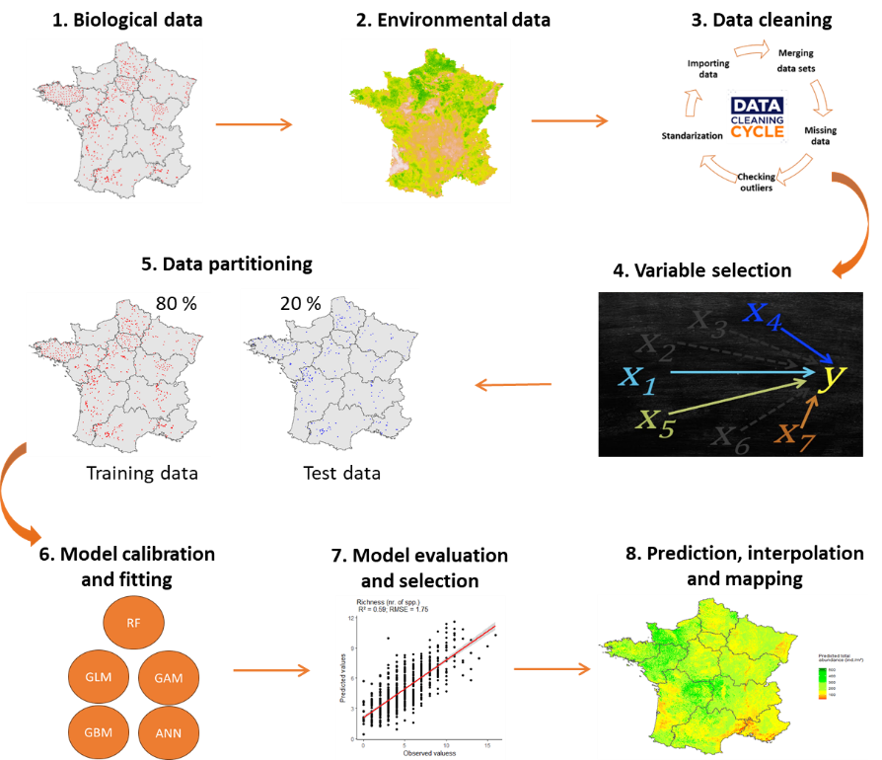

#### **Fig. 2:** Modeling strategy according to the ODMAP protocol: (1) biological data collection, (2) environmental data collection, (3) data cleaning, (4) variable selection, (5) data partitioning, (6) model calibration and fitting, (7) model evaluation and selection, and (8) Prediction, interpolation and mapping earthworm’s communities in France.

### Variable selection, importance and effects

For each of the three response variables of earthworm communities, we fitted random forest models to identify the importance of each explanatory variable (Breiman, 2001). We chose the random forest model because it can handle non-linear data, including correlated variables, and variable interactions, all of which improve model performance (Breiman, 2001). We also chose to use the random forest model to identify the most discriminating variables affecting the earthworm community and to achieve high predictive performance. To reduce the number of variables and avoid overfitting (Vaughan and Ormerod, 2005), we identified the ten most important variables on earthworms’ parameters using a permutation procedure (Fourcade and Vercauteren, 2022; Zeiss et al., 2024; Table 2): land use, longitude, latitude, calcium carbonate, nitrogen, phosphorus, clay and silt content, isothermality, and average annual precipitation. Subsequently, all fitted models used these ten selected variables. Additionally, we used the *iml* package to improve the interpretability of the models, particularly by exploring the effects of variables (Casalicchio et al., 2024). To study the effects of each variable, we used the accumulated local effects (ALE), which describe how the model’s predictions change within a small "window" of the considered variable. ALE effects are a faster and more unbiased alternative to partial dependence plots (PDP; Apley and Zhu, 2019).

#### **Table 2:** Abbreviations and descriptions of variables used in predicting earthworm communities. For the land use (boolean-type) the total sum was provided summarizing the total data set with 3 576 observations. For the continuous variables, three descriptive parameters (minimum, mean and maximum) of the final data set are provided.

|  |  |  |  |  |  |  |  |  |
| --- | --- | --- | --- | --- | --- | --- | --- | --- |
| Category | Abbr | Descriptions | Units | Min | Mean | Max | Time scale | References |
| Land use | For | Forest (116) | Boolean |  |  |  | 1990 -  2023 | LandWorm database |
| Gua | Green urban areas (535) | Boolean |  |  |  |
| Nag | Natural grasslands (111) | Boolean |  |  |  |
| Nial | Non-irrigated arable land (1683) | Boolean |  |  |  |
| Pmo | Pastures, meadows and other permanent grasslands under agricultural use (413) | Boolean |  |  |  |
| Viny | Vineyards (718) | Boolean |  |  |  |
|  |  |  |  |  |  |  |  |
| Location | Long | Longitude | WGS84 | -4.61 | 1.77 | 8.05 |  |
| Lat | Latitude | WGS84 | 43.01 | 47.50 | 50.98 |  |
|  |  |  |  |  |  |  |  |  |
| Climate | bio12 | Annual precipitation amount | kg·m-2· year-1 | 599 | 820 | 1283 | 1981 - 2010 | Karger et al. (2017) |
| bio3 | Isothermality | °C | 0.24 | 0.33 | 0.39 |
|  |  |  |  |  |  |  |  |  |
| Soil | Clay | Clay particles | g·kg -1 | 0.4 | 24.4 | 53.0 | 2022 | Roman Dobarco et al. (2022) |
| Silt | Silt particles | g·kg -1 | 2.3 | 47.0 | 81.6 |
| CaCO3 | Calcium carbonates | g·kg−1 | 0 | 75 | 332 | 2009 - 2012 | Ballabio et al. (2019) |
| P | Phosphorus | mg·kg−1 | 7.18 | 40.85 | 68.39 |
| N | Nitrogen | g·kg−1 | 0.87 | 1.99 | 3.84 |

### Model fitting and calibration

We compared five SDM algorithms to predict earthworm parameters (total abundance, total biomass, and total taxonomic richness) using 10 explanatory variables. The five algorithms were: Generalized Linear Models (GLM), Generalized Additive Models (GAM), Random Forest models (RF), Generalized Boosted Models (GBM), and Artificial Neural Networks (ANN).

We fitted GLMs using the *glm* function from the *stats* package with the following formulation:

$$Y1=glm\left(y \sim x1+x2+…+xn,family=^{'}gaussian^{'},data=data\right)$$

Where *y* was the response variable (total abundance, total biomass, or total taxonomic richness) and *x* represented the *n* explanatory variables.

For GAMs, we utilized the *gam* function from the *mgcv* package (Wood, 2023) with the following formulation:

$$Y2=gam\left(y \sim s\left(x1\right)+s\left(x2\right)+…+s\left(xn\right),family=^{'}gaussian^{'}, method = 'REML',data=data\right)$$

Where *y* was the response variable (total abundance, total biomass, or total taxonomic richness) and *x* represented the *n* explanatory variables.

Random Forest models were fitted using the *randomForest* function from the *randomForest* package (Breiman, 2001) with the following formulation:

$$Y3=randomForest\left(data\left[-rep.var\right],data\left[\left[rep.var\right]\right], mtry=3, ntree=500,maxnodes=NULL, importance=TRUE\right)$$

Where *rep.var* represented the position of the response variable column, *mtry* was the number of variables randomly sampled, *ntree* was the number of trees, and *maxnodes* was the maximum number of terminal nodes.

We performed hyperparameter tuning for Random Forest models using a grid search method with all possible combinations of the following parameters: number of variables randomly sampled (2 to 10 in increments of 1), number of trees (100 to 2000 in increments of 200), and maximum number of terminal nodes (*NULL* and 2 to 15 in increments of 1).

GBMs were fitted using the *gbm* function from the *gbm* package (Greg et al., 2024) with the following formulation:

$$Y4=gbm\left(y\sim .,data=data,distribution=^{'}gaussian^{'},n.trees=1000,shrinkage=0.01,interaction.depth=5,n.minobsinnode=10\right)$$

Where *n.trees* was the number of trees, *shrinkage* was the learning rate, *interaction.depth* was an integer specifying the maximum depth of each tree, and *n.minobsinnode* was the minimum number of observations in terminal nodes.

Several parameters needed to be selected in GBMs to control the model complexity. To choose the most appropriate parameters, we fitted the models using a grid search method with all possible combinations of the following parameters: number of trees (500 to 2000 in increments of 100), maximum depth of trees (1, 3, 5, 6, 8, 10), learning rate (0.01, 0.02, 0.05, 0.001, 0.002, 0.005), and minimum number of observations in terminal nodes (2, 5, 10, 20, 30, 50).

We used the *Keras* package (Kalinowski et al., 2024a) with a sequential architecture for ANN. The model consisted of an input layer with an *input_shape* of 15 corresponding to the 9 explanatory variables plus the 6 levels of land use that we transformed into independent binary variables (Fig. 3). We introduced 4 hidden layers with 32, 32, 16, and 8 dense neurons. The last layer consisted of a single neuron corresponding to the predicted variable (total abundance, total biomass, and total taxonomic richness). All layers were accompanied by a *ReLU* activation function except the last layer, which had a linear activation. We used the mean squared error (MSE) loss function and the *RMSprop* optimizer, while the mean absolute error (MAE) was used to evaluate model performance. For compilation, we defined epochs of 100, a *batch_size* of 64, and a *validation_split* of 0.2. To mitigate overfitting, we added four *dropout* layers and introduced an *EarlyStopping* *callback* with *patience* of 10 to monitor loss on the validation set and restore weights from the best model. We used the *tuning_run* (Kalinowski et al., 2024b) function to hyperparameterize the set of parameters explained above.

(a) (b)

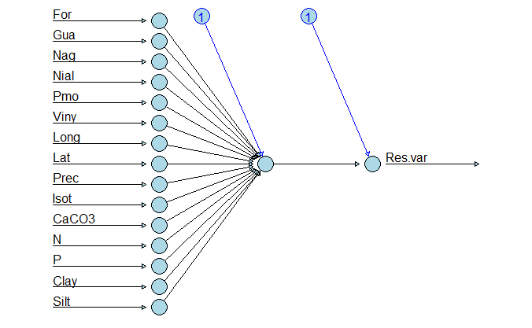

#### **Fig. 3:** Illustration of the default ANN model (a) and the optimized final model (b) with 15 input variables, including 6 land use variables. The final model consisted of 4 hidden layers with 32, 32, 16, and 8 neurons respectively.

### Model evaluation and selection

We evaluated the models using a split-sample cross-validation (CV) method by splitting and assigning 80% of the data for model training and 20% of the data for model evaluation (Horrigue et al., 2016; Hijmans and Elith, 2019; Salako et al., 2023). This method was chosen for its simplicity in understanding and implementation, as well as its quick compilation. Moreover, it proved to be effective for the large French dataset where the distribution between training and validation data was similar (non-significant Kolmogorov-Smirnov test, p-value > 0.05) (Guisan et al., 2017). The training data was used to fit the models, while the test data was used to assess the predictive performances of the models. Since all our response variables were quantitative, we chose the coefficient of determination (R²) between observations and predictions, and root mean square error (RMSE) as performance evaluation metrics.

$$RMSE=\sqrt{\frac{1}{n}\sum_{i=1}^{n}{{\left(y_{i}-\hat{y_{i}}\right)}^{2}}}$$

where: *n* was the number of observations, $y_{i}$ represented the observed value of observation (*i*) and $\hat{y_{i}}$ represented the predicted value of observation (*i*).

The objective was to maximize R² and minimize RMSE.

### Predictions, interpolation and mapping of earthworm communities

The predictions of earthworm communities were conducted using the best modeling algorithm for each of the three earthworms’ parameters (total abundance, total biomass, and total taxonomic richness). Initially, we sampled at a resolution of approximately 800 m across the entire French territory (excluding Corse). Subsequently, for each sampling point, we extracted the values of the different final variables included in the models from the databases detailed in section 2.2, whenever possible. Then, we used the *predict* function, providing the final model of the best modeling algorithm and the extracted explanatory variables to predict earthworms’ parameters. Finally, we displayed the predicted values as maps of earthworm communities. For areas where earthworms’ parameters could not be predicted, we performed interpolation using the Inverse Distance Weighting (IDW) method (Pebesma and Graeler, 2023):

$$w\left(x\right)=\frac{A}{B}$$

$$A=\sum_{i=1}^{n}{\frac{u_{i}}{{\left(d\left(x,x_{i}\right)\right)}^{p}}}$$

$$B=\sum_{i=1}^{n}{\frac{1}{{\left(d\left(x,x_{i}\right)\right)}^{p}}}$$

Where: *w* was the predicted value, *d* was the distance, *x* was the unknown point, *xi* was the n-th known point, *ui* was the value of the known point, *p* was the power coefficient (*p* = 10), and *n* was the number of sampling points used for interpolation (*n* = 10). The parameter 𝑝 was the weighting parameter that was applied as an exponent to the distance. A large 𝑝 indicated that nearby points exerted a much greater influence on the unsampled location than a distant point. Interpolation was primarily conducted in areas located within parcels where land use was not an input variable for the models. This includes heavily urbanized areas (industrial or commercial zones, airports), wetlands, or agroforestry territories. Interpolation was also performed in areas where we could not extract the variables and/or soil properties.

To estimate the approximate diversity of the earthworm community, we overlaid the map of total abundance with the map of total taxonomic richness (Salako et al., 2023).

# Results

## Model performance

The performances of the five models varied with an average R² of 0.33 (± 0.10 SD) for total abundance, 0.28 (± 0.05 SD) for biomass, and 0.48 (± 0.11 SD) for total taxonomic richness. In terms of RMSE, the average was 29 ind./m² (± 4.32 SD) for total abundance, 9.95 g/m² (± 3.69 SD) for biomass, and 1.92 species per plot (± 0.21 SD) for total taxonomic richness (Table 3). For all three earthworms’ parameters, RF and GBM exhibited the highest R² and the lowest RMSE, indicating that this algorithm provides the best prediction of the earthworm community structure. The evaluation of predictive model performances showed that GLM was the worst-performing model in predicting the total abundance, total biomass, and total taxonomic richness of earthworms.

#### **Table 3:** Performance measures of prediction on the validation dataset for different models tested on the three response variables of the earthworm community. Bold values indicate the best algorithm for each earthworm variable.

|  |  |  |  |
| --- | --- | --- | --- |
| **Model** | **Response variables** | **R²** | **RMSE** |
| GLM | Total  abundance | 0.22 | 34.57 |
| GAM | 0.26 | 33.06 |
| **RF** | **0.43** | **25.20** |
| GBM | 0.43 | 25.30 |
| ANN | 0.35 | 28.94 |
|  |  |  |  |
| GLM | Total  biomass | 0.23 | 10.69 |
| GAM | 0.24 | 10.50 |
| **RF** | **0.35** | **8.76** |
| GBM | 0.32 | 9.30 |
| ANN | 0.27 | 10.50 |
|  |  |  |  |
| GLM | Total  taxonomic  richness | 0.36 | 2.18 |
| GAM | 0.44 | 2.04 |
| **RF** | **0.59** | **1.75** |
| GBM | **0.59** | **1.75** |
| ANN | 0.40 | 2.16 |

Fig. 4 illustrates the comparison between observed values (test dataset) and values predicted by the best models. For total abundance, the best model was RF with an R² of 0.43. Similarly, RF was also the best model for total biomass with an R² of 0.35. For total taxonomic richness, the best models were RF and GBM, both with identical R² values of 0.59.

#### **Fig. 4:** Prediction on the test dataset with the best algorithms for (a) total abundance (RF), (b) total biomass (RF), and (c) total taxonomic richness (GBM). The X-axis indicates the observed values, and the Y-axis indicates the predicted values. The red line represents the linear regression (trend) between the observed and predicted values, and the gray band indicates the confidence interval around the regression line.

## Importance of the environmental variables

The most important variable was the land use (CLC; Fig. 5). When land use was permuted, the RMSE of the total abundance model increased on average by 1.68 ind./m² for total abundance, by 1.45 g/m² for biomass, and by 1.78 species per plot for the earthworm total taxonomic richness. After land use, spatial variables were the most important ones for predicting earthworms’ parameters, particularly longitude, which led to an average increase in RMSE of 1.63 species per plot. Regarding climatic variables, annual precipitation was the most important for earthworm prediction. The two most influential soil variables on earthworms’ parameters were calcium carbonate (CaCO₃) and nitrogen (N), respectively. CaCO₃ was also found to have a great influence on total taxonomic richness and total abundance compared to biomass.

#### **Fig. 5:** Importance of environmental explanatory variables for predicting total abundance (RF), total biomass (RF), and total taxonomic richness (GBM) of earthworms. Values represent the median increase in RMSE (plus or minus the 5% and 95% quantiles with n = 5) of model prediction after the permutation of variable values.

## Effects of the environmental variables on earthworm communities

Analyses of Accumulated Local Effects (ALE) showed that land use had mixed effects on the earthworm community. For example, grassland plots (Nag and Pmo) had the highest earthworm total abundances and showed the highest predicted increase in total abundance by 80 ind./m². Similarly, plots located in urban green areas (Gua) predicted total abundance increased by 50 ind./m². Plots in Nag, Pmo, and Gua had about one or two more species than any other land use types. ALE effects also showed that plots in vineyards (Viny), forests (For), and annual crops (Nial) were associated with the lowest total earthworm abundance. Regarding biomass, only grasslands showed an increase in the predicted average weight of earthworms.

Spatial variables also exerted a strong influence on earthworms’ parameters, with longitude having the most significant impact. Moving from west to east of France, earthworm total abundance and total taxonomic richness decreased, with a decrease of about 50 ind./m² and one species, respectively, whereas biomass showed very little variations. Increasing latitude did not influence total abundance between 43°N and 46°N but decreased between 46°N and 47.5°N before increasing beyond the latter latitude.

Regarding the effect of climatic variables, an increase in annual precipitation up to 700 kg·m-2·year-1 resulted in an increase in predicted total abundance by approximately 15 ind./m². Beyond this threshold, abundance remained stable. Similarly, an increase in annual precipitation up to 700 kg·m-2·year-1 led to an increase in total biomass, but biomass gradually decreased beyond this threshold. In contrast, total richness decreased when annual precipitation was below 900 kg·m-2·year-1 and increased above this threshold. Additionally, earthworms were little affected by the ratio between diurnal temperature variation and annual variation (Isot).

Regarding soil properties, increasing CaCO₃ up to approximately 10 g·kg-1 led to an increase in predicted total abundance by 25 ind./m² and predicted total biomass by 15 g/m². However, values above 10 g·kg-1 CaCO₃ led to a decrease in total abundance and total biomass. Increasing CaCO₃ from 0 to 100 g·kg-1 resulted in a decrease of one species, but the taxonomic richness remained stable beyond 100 g·kg−1. Soil nitrogen was positively correlated with total abundance, total biomass and total taxonomic richness. In addition, increasing nitrogen from 1 to 3 g-kg-1 increased total abundance by 25 ind./m², total biomass by 10 g/m² and total taxonomic richness by one species. Soil texture (clay and silt content) did not influence predicted total abundance up to 40 g·kg-1, but higher values resulted in increases in total abundance, reaching an average predicted increase of 45 ind./m². The texture had little influence on total biomass. Phosphorus had a minor negative effect on earthworm communities.

## Spatial distribution of earthworms at the scale of France

Figure 6 shows the predicted spatial distribution of the earthworm communities in France (excluding Corse). Total predicted total abundance varied from 0 to 530 ind./m² with a mean of 192 ind./m² per plot (Fig. 6a). The average predicted biomass was 72 g/m² (minimum = 0 and maximum = 196; Fig. 6b), while predicted total taxonomic richness ranged from 0 to 10 with a mean of 5 species per plot (Fig. 6c). Figure 6d represents the approximate diversity of earthworms resulting from the overlay of the total abundance map and the total taxonomic richness map.

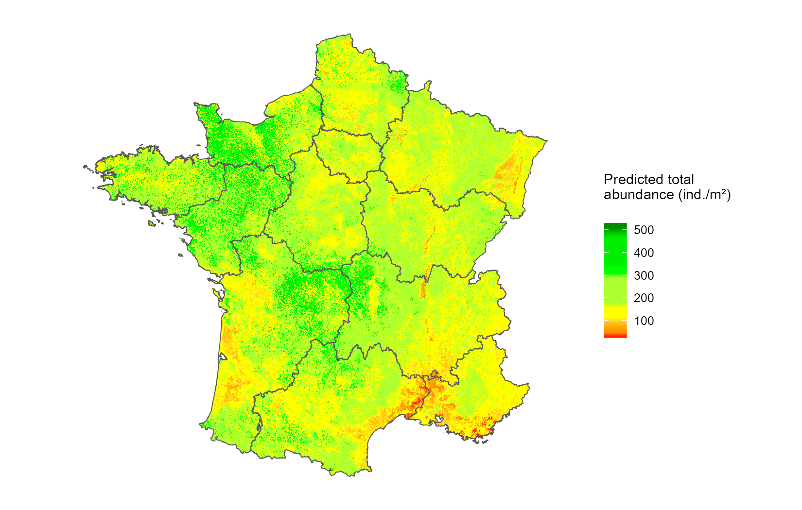

(a)

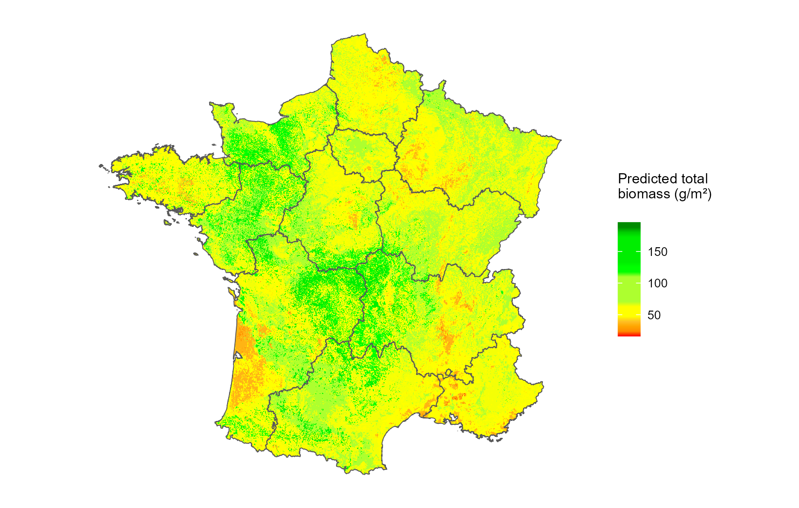

(b)

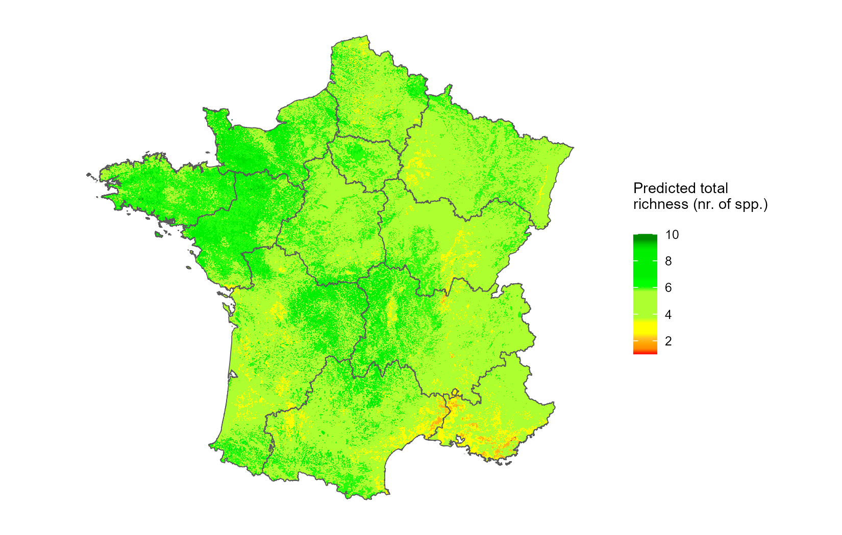

(c)

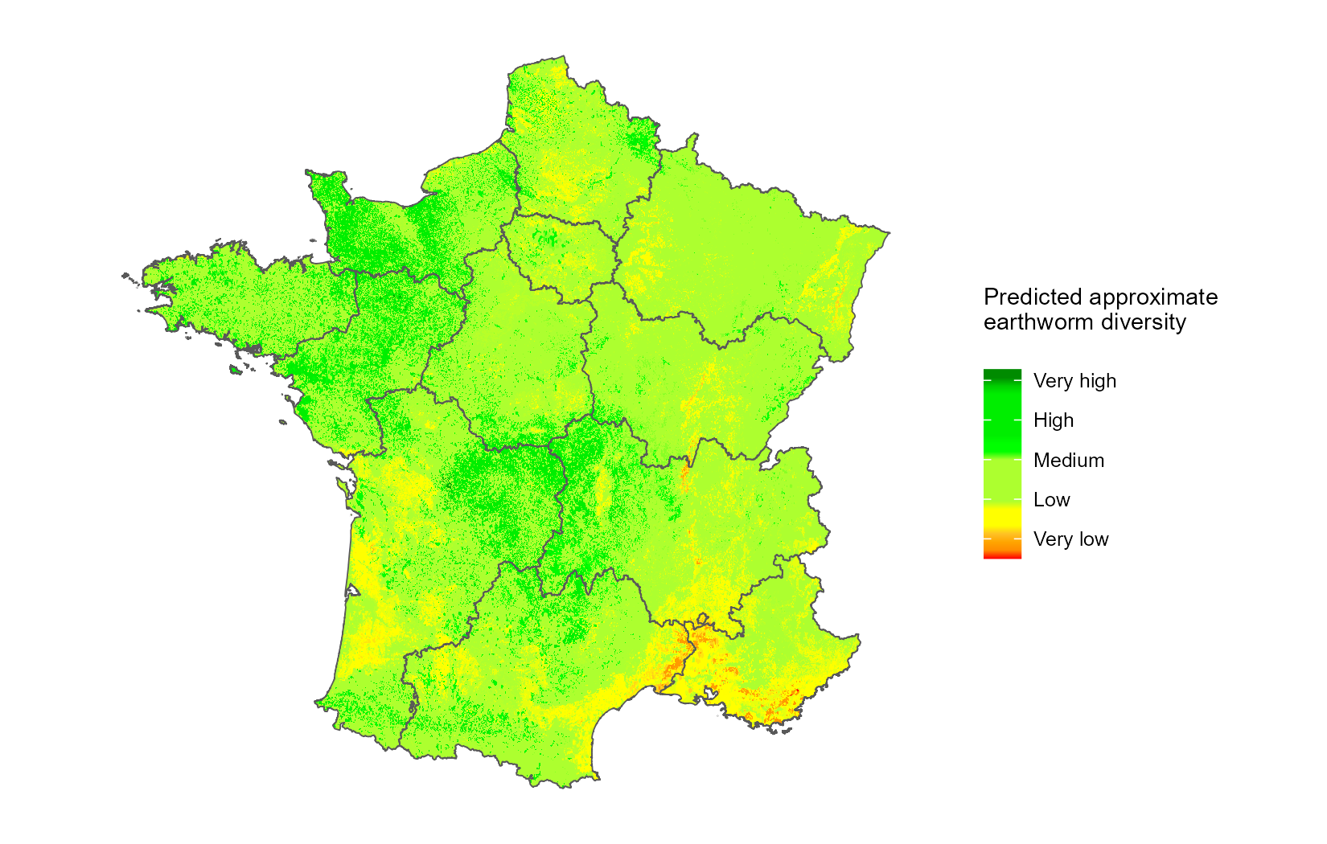

(d)

#### **Fig. 6:** Predicted spatial distribution of (a) total abundance (ind./m²), (b) total biomass (g/m²), (c) total taxonomic richness (number of taxa per plot), and (d) approximate diversity of earthworms. Legend: Very low (total abundance < 100 ind./m² and total taxonomic richness < 2 species); Low (total abundance < 200 ind./m² and total taxonomic richness < 4 species); Medium (total abundance < 300 ind./m² and total taxonomic richness < 6 species); High (total abundance < 400 ind./m² and total taxonomic richness < 8 species); Very high (total abundance > 500 ind./m² and total taxonomic richness > 10 species).

# Discussion

## Improved performance of ensemble methods when predicting earthworm communities

The adjustment of five different modeling algorithms to predict the distribution of earthworms’ parameters using land use, spatial, climatic, and soil variables allowed us to determine the accuracy of the models tested. Our comparative approach showed that earthworm total abundance was predicted with an R² of 0.43 (RMSE = 25 ind./m²), total biomass with an R² of 0.35 (RMSE = 8.76 g/m²), and total taxonomic richness with an R² of 0.59 (RMSE = 1.7 species per plot). These predictive performances fall within the intermediate range of values, consistent with previous studies. Indeed, Rutgers et al. (2016) observed R² values of 0.252 for abundance and 0.249 for richness, while Salako et al. (2023) found R² values of 0.840 for abundance and 0.574 for richness. Furthermore, compared to other biological models, the predictive performances of our models remain relevant. Oppel et al. (2012) found an R² of 0.45 for the density (birds/km²) of *Balearic shearwaters*, while for soil molecular microbial biomass, Horrigue et al. (2016) found an adjusted coefficient of determination of 0.67.

Our results demonstrate that random forest (RF) models and generalized boosted models (GBM) provided better results of predicted earthworm total abundance, total biomass, and total taxonomic richness compared to traditional regression models (GLM and GAM) and artificial neural networks (ANN). This finding aligns with those of Li & Wang (2013); Mi et al. (2017); Valavi et al. (2021) who also observed that RF had very high predictive performances. Similarly, Salako et al. (2023) using different prediction algorithms concluded that RF was the most effective algorithm for predicting earthworm communities in Germany. The high performances of these algorithms can be attributed to the fact that RF and GBM act as ensemble classifiers, utilizing multiple alternative trees in decision-making during model predictions (Breiman, 2001; Li and Wang, 2013). Their effectiveness also stems from their ability to capture better nonlinear relationships between explanatory and response variables, robustness against outliers, and better handling of variable interactions (Breiman, 2001). Considering the high predictive potential of RF and GBM, it would be advisable to use them in ecological studies (especially on the earthworm community) instead of or in addition to traditional regression algorithms alone (Rutgers et al., 2016; Phillips et al., 2019). However, RF and GBM require substantial amounts of data to achieve good predictive performances (Yiu, 2021). From this, it is clear that model performances would be improved if several databases could be merged and standardized (e.g., derived from different research units and across countries). Another limitation of RF and GBM is their low degree of interpretability, but this is becoming less true as numerous tools now exist to better understand and interpret machine learning models. For example, the *iml* package provides very useful tools for analyzing any black-box machine-learning model. The package allows for exploring the importance, effects, and interactions of variables while also proposing surrogate models (Casalicchio et al., 2024).

## Importance and effects of environmental variables

Our results demonstrated that land use was the most important variable on earthworms’ parameters. This is consistent with the findings of Rutgers et al. (2016); Fourcade and Vercauteren (2022) and Salako et al. (2023), which showed that land use strongly affects the distribution of earthworm communities. All predictive models used in this study predicted the positive effects of grasslands (Pmo and Nag) on earthworms’ parameters. Our models predicted a high number of earthworms (80 ind./m²), average biomass (40 g/m²), and approximately one to two species in grasslands compared to the other land uses. These results can be explained by the fact that grassland plots are conducive to the development and growth of earthworms, providing more food resources, refuge from predators, and protection against extreme climatic events (Iordache, 2010; Zhu and Zhu, 2015; Niswati et al., 2022). However, many parameters can mitigate this effect of grasslands: for example, the use of inputs, frequency of grazing by cattle, stocking density, mowing management and seasonality (Postma-Blaauw et al., 2006; van der Wal et al., 2009; Cluzeau et al., 2012). Our models also predicted a negative effect of crops and vineyards. This is coherent because it is known that land use intensity can have a negative impact on earthworm communities (Smith et al., 2008; Spurgeon et al., 2013). These negative effects of intensive agriculture can be mainly attributed to the significant impact of soil tillage, fertilization, and pesticides (Pelosi et al., 2013, 2014; Maggi and Tang, 2021; Niswati et al., 2022). For example, in a global meta-analysis, Briones and Schmidt (2017) showed that disturbing the soil less (no-tillage and conservation agriculture) significantly increased earthworm abundance (mean increase of 137% and 127%, respectively) and biomass (196% and 101%, respectively) compared to conventional ploughing. The low earthworm community in forests could be explained by the fact that food resources may not be easily assimilable by earthworms due to the presence of lignin, which makes the food resources harder to degrade (De Wandeler et al., 2016).

After land use, the variables with the greatest influence on earthworms’ parameters were spatial variables. We observed that the earthworm community was more abundant in the northwest and center of France compared to the east of the country. This result is consistent with the findings of Zeiss et al. (2024), who also observed that earthworm total taxonomic richness was high in the west-central part of Europe and low in the northeast. Furthermore, Rutgers et al. (2016) concluded that the large-scale distribution of earthworm densities was positively correlated with latitude, longitude, and climatic factors at the European scale. These discrepancies with our study could be explained by the differences in land use: more grasslands plots were sampled in the west, while the east forests and vineyard plots were more abundant. This result could also be explained by the fact that longitude and latitude may obscure climatic variables. Indeed, moving eastward, one encounters a continental climate characterized by harsher summers and winters, leading to more pronounced climatic extremes than those included in the selected variables (Joly et al., 2010). The Mediterranean climate, on the other hand, also has specific features that can be captured by geographic coordinates. It is possible that climatic variables initially present (average temperatures of the hottest or coldest quarters and average precipitation of the wettest or driest quarters), but not retained during the selection of the most important variables by the Random Forest (RF) model, were actually linked to longitude and latitude. This potential bias constitutes a limitation of our study.

Regarding climate, our study demonstrated the positive effect of precipitation on earthworm communities, confirming the results of Rutgers et al. (2016), Salako et al. (2023) and Zeiss et al. (2024). It has been shown that various climatic factors, such as temperature, precipitation, soil moisture, and extreme weather events like droughts and floods, alter the composition and functioning of soil communities (Singh et al., 2019). Moreover, at global scales and according to Phillips et al. (2019), the most influential variables on earthworms’ parameters (abundance and richness) are precipitation and annual temperature. This is because climatic parameters play a crucial role at large spatial scales (Rutgers et al., 2016; Phillips et al., 2019), while soil-related factors become more important at local spatial scales (Palm et al., 2013; Marchán et al., 2015). We found that increasing precipitation up to approximately 700 kg·m-2·year-1 increased total abundance and total biomass. This result could be explained by the fact that up to this threshold, moisture conditions were suitable for earthworms (Edwards and Arancon, 2022). Beyond 700 kg·m-2·year-1, total abundance remained constant, while total biomass gradually decreased. This observation could be due to the fact that the increased frequency and intensity of extreme precipitation events can lead to mortality by altering the life cycle and nutrition of soil animals (Bates et al., 2008; Thakur et al., 2018), as well as making soils more vulnerable to erosion (Nearing et al., 2004) and impairing their habitat function for soil fauna (Singh et al., 2019). However, we believe that the effect of precipitation beyond 900 kg·m-2·year-1 was not very reliable because we did not have enough observations with high precipitation levels. This would have influenced the accumulated local effects (ALE), which are sensitive to the number of observations and the number of intervals chosen for each environmental variable.

Although our study confirmed the combined role of land use, spatial variables, and precipitation, it also identified soil variables such as CaCO₃, soil texture, and nitrogen as important factors. Indeed, CaCO₃ had positive effects on earthworms’ parameters below 10 g·kg⁻¹ and negative effects beyond this threshold. This result could be explained by the fact that low amounts of CaCO₃ would favor the alkalinization of food and facilitate the passage of food at the level of Morren's glands, while high amounts of CaCO₃ would be toxic to earthworms. We found that soil texture (clay and silt content) above 40 g·kg⁻¹ increased the total abundance of earthworms. This result is consistent with the conclusions of Edwards and Arancon (2022), who state that silts generally favor earthworm populations. Coarse elements such as sands are easier to burrow through but harder to ingest, are abrasive, and very draining, which accentuates the “drought” for earthworms. In contrast, finer and denser textures slow down movement but are more easily ingested by geophages (Perreault and Whalen, 2006). However, other factors such as the presence of organic matter, vegetation, management practices, and soil pH, as well as their interactions, can greatly influence earthworm abundance and activity (Hoeffner et al., 2021; Edwards and Arancon, 2022). In this study, increasing nitrogen was positively correlated with all three earthworms’ parameters. This increase in the earthworm community as nitrogen levels rise could be explained by the fact that increased nitrogen boosts primary production, which, for earthworms, increases food supply and provides refuge from predators and extreme climatic events (Iordache, 2010; Zhu and Zhu, 2015; Niswati et al., 2022).

## Limitations and considerations in earthworm distribution modeling

We are aware that there are other variables not included in this study that can strongly influence earthworms, such as tillage (Ernst and Emmerling, 2009; Crittenden et al., 2014; Pelosi et al., 2014; Briones and Schmidt, 2017), pesticides (Pelosi et al., 2013; Maggi and Tang, 2021), fertilization (Leroy et al., 2008; Niswati et al., 2022) and others land use practices. However, these variables are not available in high-resolution maps at a national scale. Despite this shortcoming, our study includes a large number of the most important environmental variables known to affect earthworms (Edwards and Arancon, 2022).

We predicted the distribution of earthworms in areas for which we were able to extract model predictors through high-resolution maps, as well as in some additional areas to produce continuous maps. These additional areas were mainly located in plots with land uses that are not input variables of the models. These include highly artificialized areas (industrial or commercial zones, airports), wetlands, water surfaces, or agroforestry territories. The expected distributions of earthworms in these areas were indirectly derived by interpolation and should therefore be interpreted with caution (Rutgers et al., 2016).

It is important to note that the explanatory variables related to climate and soil properties come from external databases, as not all plots in our database contained this information. However, this reliance on external databases constitutes a limitation, as already noted by Rutgers et al. (2016) and Salako et al. (2023). Indeed, the quality of the data used during model training greatly influences their performance. For this reason, we chose not to use external databases for land use because this information was well documented in our database, and thus, preventing the temporal gap between collecting earthworm observations and land use changes over time. Another limitation of our study lies in the restricted selection of land use types (six types of level 3 land use defined by Corine Land Cover) due to the lack of available data (Edwards and Arancon, 2022). Additionally, we could not distinguish between broad-leaved forests and mixed forests and grouped these three types of forests under a single land use type: "Forest" (all types; 116 observations). This decision was made considering that land use has a significant impact on earthworm populations, as highlighted by Spurgeon et al. (2013). We are also aware that our database was unbalanced in terms of sampling, with more observations in the north than in the south, which could explain the low R² for total biomass, especially since some earthworm observations had no biomass.

# Conclusion

In this study, we developed a comparative approach between traditional regression models (GLM, GAM) and machine learning algorithms (RF, GBM, and ANN) to identify the best model for predicting the earthworm community in France. Generalized boosted models and random forests showed the best predictive performances. The notable initial results we obtained pertain to the estimated precision of our models, which enable prediction of total biomass with an R² of 0.35 (RMSE = 8.76 g/m²), total abundance with an R² of 0.43 (RMSE = 25 ind./m²), and total taxonomic richness with an R² of 0.59 (RMSE = 1.7 species per plot). Our study highlighted that land use was the most important variable for earthworms, followed by spatial, climatic, and soil variables. Additionally, our study created prediction maps of the earthworm community in France. To complement this study and obtain a comprehensive overview of the earthworm community in France, it would be relevant to develop additional models to predict species total abundance or presence-absence, as well as the total abundance and total biomass of specific ecological categories of earthworms.

# References

Apley, D.W., Zhu, J., 2019. Visualizing the Effects of Predictor Variables in Black Box Supervised Learning Models. https://doi.org/10.48550/arXiv.1612.08468

Ballabio, C., Lugato, E., Fernández-Ugalde, O., Orgiazzi, A., Jones, A., Borrelli, P., Montanarella, L., Panagos, P., 2019. Mapping LUCAS topsoil chemical properties at European scale using Gaussian process regression. Geoderma 355, 113912. https://doi.org/10.1016/j.geoderma.2019.113912

Bardgett, R.D., Van der Putten, W.H., 2014. Belowground biodiversity and ecosystem functioning. Nature 515, 505–511. https://doi.org/10.1038/nature13855

Bates, B., Kundzewicz, Z., Wu, S., 2008. Climate Change and Water. Intergovernmental Panel on Climate Change Secretariat.

Blouin, M., Hodson, M.E., Delgado, E.A., Baker, G., Brussaard, L., Butt, K.R., Dai, J., Dendooven, L., Peres, G., Tondoh, J.E., Cluzeau, D., Brun, J.-J., 2013. A review of earthworm impact on soil function and ecosystem services: Earthworm impact on ecosystem services. Eur. J. Soil Sci. 64, 161–182. https://doi.org/10.1111/ejss.12025

Breiman, L., 2001. Random Forests. Mach. Learn. 45, 5–32. https://doi.org/10.1023/A:1010933404324

Briones, M.J.I., Schmidt, O., 2017. Conventional tillage decreases the abundance and biomass of earthworms and alters their community structure in a global meta-analysis. Glob. Change Biol. 23, 4396–4419. https://doi.org/10.1111/gcb.13744

Capowiez, Y., Sammartino, S., Michel, E., 2014. Burrow systems of endogeic earthworms: Effects of earthworm abundance and consequences for soil water infiltration. Pedobiologia 57, 303–309. https://doi.org/10.1016/j.pedobi.2014.04.001

Cardinale, B.J., Duffy, J.E., Gonzalez, A., Hooper, D.U., Perrings, C., Venail, P., Narwani, A., Mace, G.M., Tilman, D., Wardle, D.A., Kinzig, A.P., Daily, G.C., Loreau, M., Grace, J.B., Larigauderie, A., Srivastava, D.S., Naeem, S., 2012. Biodiversity loss and its impact on humanity. Nature 486, 59–67. https://doi.org/10.1038/nature11148

Casalicchio, G., Molnar, C., Schratz, P., 2024. iml: Interpretable Machine Learning.

Cluzeau, D., Guernion, M., Chaussod, R., Martin-Laurent, F., Villenave, C., Cortet, J., Ruiz-Camacho, N., Pernin, C., Mateille, T., Philippot, L., Bellido, A., Rougé, L., Arrouays, D., Bispo, A., Pérès, G., 2012. Integration of biodiversity in soil quality monitoring: Baselines for microbial and soil fauna parameters for different land-use types. Eur. J. Soil Biol., Bioindication in Soil Ecosystems 49, 63–72. https://doi.org/10.1016/j.ejsobi.2011.11.003

Crittenden, S.J., Eswaramurthy, T., de Goede, R.G.M., Brussaard, L., Pulleman, M.M., 2014. Effect of tillage on earthworms over short- and medium-term in conventional and organic farming. Appl. Soil Ecol., XVI International Colloquium on Soil Zoology & XIII International Colloquium on Apterygota, Coimbra, 2012 – Selected papers 83, 140–148. https://doi.org/10.1016/j.apsoil.2014.03.001

Cunha, L., Brown, G.G., Stanton, D.W.G., Da Silva, E., Hansel, F.A., Jorge, G., McKey, D., Vidal-Torrado, P., Macedo, R.S., Velasquez, E., James, S.W., Lavelle, P., Kille, P., Network, the T.P. de I., 2016. Soil Animals and Pedogenesis: The Role of Earthworms in Anthropogenic Soils. Soil Sci. 181, 110–125. https://doi.org/10.1097/SS.0000000000000144

De Wandeler, H., Sousa-Silva, R., Ampoorter, E., Bruelheide, H., Carnol, M., Dawud, S.M., Dănilă, G., Finer, L., Hättenschwiler, S., Hermy, M., Jaroszewicz, B., Joly, F.-X., Müller, S., Pollastrini, M., Ratcliffe, S., Raulund-Rasmussen, K., Selvi, F., Valladares, F., Van Meerbeek, K., Verheyen, K., Vesterdal, L., Muys, B., 2016. Drivers of earthworm incidence and abundance across European forests. Soil Biol. Biochem. 99, 167–178. https://doi.org/10.1016/j.soilbio.2016.05.003

Diallo, A., Hoeffner, K., Guillocheau, S., Sorgniard, P., Cluzeau, D., 2023. Combined effects of annual crop agricultural practices on earthworm communities. Appl. Soil Ecol. 192, 105073. https://doi.org/10.1016/j.apsoil.2023.105073

Edwards, C.A., Arancon, N.Q., 2022. Biology and Ecology of Earthworms. Springer US, New York, NY. https://doi.org/10.1007/978-0-387-74943-3

Elith, J., Graham, C.H., 2009. Do they? How do they? WHY do they differ? On finding reasons for differing performances of species distribution models. Ecography 32, 66–77. https://doi.org/10.1111/j.1600-0587.2008.05505.x

Elith, J., H. Graham*, C., P. Anderson, R., Dudík, M., Ferrier, S., Guisan, A., J. Hijmans, R., Huettmann, F., R. Leathwick, J., Lehmann, A., Li, J., G. Lohmann, L., A. Loiselle, B., Manion, G., Moritz, C., Nakamura, M., Nakazawa, Y., McC. M. Overton, J., Townsend Peterson, A., J. Phillips, S., Richardson, K., Scachetti-Pereira, R., E. Schapire, R., Soberón, J., Williams, S., S. Wisz, M., E. Zimmermann, N., 2006. Novel methods improve prediction of species’ distributions from occurrence data. Ecography 29, 129–151. https://doi.org/10.1111/j.2006.0906-7590.04596.x

Elith, J., Leathwick, J.R., 2009. Species Distribution Models: Ecological Explanation and Prediction Across Space and Time. Annu. Rev. Ecol. Evol. Syst. 40, 677–697. https://doi.org/10.1146/annurev.ecolsys.110308.120159

Ernst, G., Emmerling, C., 2009. Impact of five different tillage systems on soil organic carbon content and the density, biomass, and community composition of earthworms after a ten year period. Eur. J. Soil Biol. 45, 247–251. https://doi.org/10.1016/j.ejsobi.2009.02.002

FAO, I., 2020. State of knowledge of soil biodiversity – Status, challenges and potentialities. Summary for policy makers.

Fourcade, Y., Vercauteren, M., 2022. Predicted changes in the functional structure of earthworm assemblages in France driven by climate change. Divers. Distrib. 28, 1050–1066. https://doi.org/10.1111/ddi.13505

Gabriac, Q., Ganault, P., Barois, I., Aranda-Delgado, E., Cimetière, E., Cortet, J., Gautier, M., Hedde, M., Marchán, D.F., Reyes, J.C.P., Stokes, A., Decaëns, T., 2022. Environmental drivers of earthworm communities along an altitudinal gradient in the French Alps. https://doi.org/10.1101/2022.10.13.512055

Greg, R., Edwards, D., Kriegler, B., Schroedl, S., Southworth, H., Greenwell, B., Boehmke, B., Cunningham, J., Developers (https://github.com/gbm-developers), G.B.M., 2024. gbm: Generalized Boosted Regression Models.

Guisan, A., Thuiller, W., Zimmermann, N.E., 2017. Habitat Suitability and Distribution Models: With Applications in R, Ecology, Biodiversity and Conservation. Cambridge University Press, Cambridge. https://doi.org/10.1017/9781139028271

Hijmans, R.J., Elith, J., 2019. Spatial Distribution Models.

Hoeffner, K., Hotte, H., Cluzeau, D., Charrier, X., Gastal, F., Pérès, G., 2021. Effects of temporary grassland introduction into annual crop rotations and nitrogen fertilisation on earthworm communities and forage production. Appl. Soil Ecol. 162, 103893. https://doi.org/10.1016/j.apsoil.2021.103893

Hooper, D.U., Adair, E.C., Cardinale, B.J., Byrnes, J.E.K., Hungate, B.A., Matulich, K.L., Gonzalez, A., Duffy, J.E., Gamfeldt, L., O’Connor, M.I., 2012. A global synthesis reveals biodiversity loss as a major driver of ecosystem change. Nature 486, 105–108. https://doi.org/10.1038/nature11118

Horrigue, W., Dequiedt, S., Chemidlin Prévost-Bouré, N., Jolivet, C., Saby, N.P.A., Arrouays, D., Bispo, A., Maron, P.-A., Ranjard, L., 2016. Predictive model of soil molecular microbial biomass. Ecol. Indic. 64, 203–211. https://doi.org/10.1016/j.ecolind.2015.12.004

Iordache, M., 2010. Abundance of earthworms under fertilization with organo-mineral fertilizers in a chernozem from west of Romania. J. Food Agric. Environ. 10, 1103–1105.

Joly, D., Brossard, T., Cardot, H., Cavailhes, J., Hilal, M., Wavresky, P., 2010. Les types de climats en France, une construction spatiale. Cybergeo. https://doi.org/10.4000/cybergeo.23155

Jones, C.G., Lawton, J.H., Shachak, M., 1994. Organisms as Ecosystem Engineers, in: Samson, F.B., Knopf, F.L. (Eds.), Ecosystem Management: Selected Readings. Springer, New York, NY, pp. 130–147. https://doi.org/10.1007/978-1-4612-4018-1_14

Kalinowski, T., Falbel, D., Allaire, J.J., Chollet, F., RStudio, Google, Tang [ctb, Y., cph, Bijl, W.V.D., Studer, M., Keydana, S., 2024a. keras: R Interface to “Keras.”

Kalinowski, T., Falbel, D., Allaire, J.J., RStudio, https://d3js.org/), M.B. (D3 library-, http://c3js.org/), M.T. (C3 library-, library), jQuery F. (jQuery, inst/views/components/jquery-AUTHORS.txt), jQuery contributors (jQuery library; authors:, plugin), S.B. (jQuery visibilityChanged, https://materializecss.com/), M. (Materizlize library-, https://vuejs.org/), Y.Y. (Vue js library-, https://github.com/kpdecker/jsdiff/), K.D. (jsdiff library-, https://diff2html.xyz/), R.F. (diff2html library-, https://highlightjs.org/), I.S. (highlight js library-, library), Y.P. (highlightjs-line-numbers, 2024b. tfruns: Training Run Tools for “TensorFlow.”

Karger, D.N., Conrad, O., Böhner, J., Kawohl, T., Kreft, H., Soria-Auza, R.W., Zimmermann, N.E., Linder, H.P., Kessler, M., 2017. Climatologies at high resolution for the earth’s land surface areas. Sci. Data 4, 170122. https://doi.org/10.1038/sdata.2017.122

Lavelle, P., Bignell, D., Lepage, M., Wolters, V., Roger, P., Ineson, P., Heal, O.W., Dhillion, S., 1997. Soil function in a changing world: the role of invertebrate ecosystem engineers. Eur. J. Soil Biol.

Leroy, B.L.M., Schmidt, O., Van den Bossche, A., Reheul, D., Moens, M., 2008. Earthworm population dynamics as influenced by the quality of exogenous organic matter. Pedobiologia 52, 139–150. https://doi.org/10.1016/j.pedobi.2008.07.001

Li, X., Wang, Y., 2013. Applying various algorithms for species distribution modelling. Integr. Zool. 8, 124–135. https://doi.org/10.1111/1749-4877.12000

Maggi, F., Tang, F.H.M., 2021. Estimated decline in global earthworm population size caused by pesticide residue in soil. Soil Secur. 5, 100014. https://doi.org/10.1016/j.soisec.2021.100014

Marchán, D.F., Csuzdi, C., Decaëns, T., Szederjesi, T., Pizl, V., Domínguez, J., 2021. The disjunct distribution of relict earthworm genera clarifies the early historical biogeography of the Lumbricidae (Crassiclitellata, Annelida). J. Zool. Syst. Evol. Res. 59, 1703–1717. https://doi.org/10.1111/jzs.12514

Marchán, D.F., Domínguez, J., 2022. Evaluating the Conservation Status of a North-Western Iberian Earthworm (Compostelandrilus cyaneus) with Insight into Its Genetic Diversity and Ecological Preferences. Genes 13, 337. https://doi.org/10.3390/genes13020337

Marchán, D.F., Refoyo, P., Fernández, R., Novo, M., de Sosa, I., Díaz Cosín, D.J., 2016. Macroecological inferences on soil fauna through comparative niche modeling: The case of Hormogastridae (Annelida, Oligochaeta). Eur. J. Soil Biol. 75, 115–122. https://doi.org/10.1016/j.ejsobi.2016.05.003

Marchán, D.F., Refoyo, P., Novo, M., Fernández, R., Trigo, D., Díaz Cosín, D.J., 2015. Predicting soil micro-variables and the distribution of an endogeic earthworm species through a model based on large-scale variables. Soil Biol. Biochem. 81, 124–127. https://doi.org/10.1016/j.soilbio.2014.10.023

Mi, C., Huettmann, F., Guo, Y., Han, X., Wen, L., 2017. Why choose Random Forest to predict rare species distribution with few samples in large undersampled areas? Three Asian crane species models provide supporting evidence. PeerJ 5, e2849. https://doi.org/10.7717/peerj.2849

Nearing, M.A., Pruski, F.F., O’Neal, M.R., 2004. Expected climate change impacts on soil erosion rates: A review. J. Soil Water Conserv. 59, 43–50.

Niswati, A., Liyana, Prasetyo, D., Lumbanraja, J., 2022. Abundance and biomass of earthworm as affected by long-term different types of soil tillage and fertilization on mung bean plantation at Ultisols. IOP Conf. Ser. Earth Environ. Sci. 1018, 012012. https://doi.org/10.1088/1755-1315/1018/1/012012

Oppel, S., Meirinho, A., Ramírez, I., Gardner, B., O’Connell, A.F., Miller, P.I., Louzao, M., 2012. Comparison of five modelling techniques to predict the spatial distribution and abundance of seabirds. Biol. Conserv., Seabirds and Marine Protected Areas planning 156, 94–104. https://doi.org/10.1016/j.biocon.2011.11.013

Palm, J., van Schaik, N.L.M.B., Schröder, B., 2013. Modelling distribution patterns of anecic, epigeic and endogeic earthworms at catchment-scale in agro-ecosystems. Pedobiologia 56, 23–31. https://doi.org/10.1016/j.pedobi.2012.08.007

Pebesma, E., Graeler, B., 2023. gstat: Spatial and Spatio-Temporal Geostatistical Modelling, Prediction and Simulation.

Pelosi, C., Pey, B., Hedde, M., Caro, G., Capowiez, Y., Guernion, M., Peigné, J., Piron, D., Bertrand, M., Cluzeau, D., 2014. Reducing tillage in cultivated fields increases earthworm functional diversity. Appl. Soil Ecol., XVI International Colloquium on Soil Zoology & XIII International Colloquium on Apterygota, Coimbra, 2012 – Selected papers 83, 79–87. https://doi.org/10.1016/j.apsoil.2013.10.005

Pelosi, Toutous, L., Chiron, F., Dubs, F., Hedde, M., Muratet, A., Ponge, J.-F., Salmon, S., Makowski, D., 2013. Reduction of pesticide use can increase earthworm populations in wheat crops in a European temperate region. Agric. Ecosyst. Environ. 181, 223–230. https://doi.org/10.1016/j.agee.2013.10.003

Perreault, J.M., Whalen, J.K., 2006. Earthworm burrowing in laboratory microcosms as influenced by soil temperature and moisture. Pedobiologia 50, 397–403. https://doi.org/10.1016/j.pedobi.2006.07.003

Peterson, R.A., 2023. bestNormalize: Normalizing Transformation Functions.

Phillips, H.R.P., Guerra, C.A., Bartz, M.L.C., Briones, M.J.I., Brown, G., Crowther, T.W., Ferlian, O., Gongalsky, K.B., van den Hoogen, J., Krebs, J., Orgiazzi, A., Routh, D., Schwarz, B., Bach, E.M., Bennett, J.M., Brose, U., Decaëns, T., König-Ries, B., Loreau, M., Mathieu, J., Mulder, C., van der Putten, W.H., Ramirez, K.S., Rillig, M.C., Russell, D., Rutgers, M., Thakur, M.P., de Vries, F.T., Wall, D.H., Wardle, D.A., Arai, M., Ayuke, F.O., Baker, G.H., Beauséjour, R., Bedano, J.C., Birkhofer, K., Blanchart, E., Blossey, B., Bolger, T., Bradley, R.L., Callaham, M.A., Capowiez, Y., Caulfield, M.E., Choi, A., Crotty, F.V., Crumsey, J.M., Dávalos, A., Diaz Cosin, D.J., Dominguez, A., Duhour, A.E., van Eekeren, N., Emmerling, C., Falco, L.B., Fernández, R., Fonte, S.J., Fragoso, C., Franco, A.L.C., Fugère, M., Fusilero, A.T., Gholami, S., Gundale, M.J., López, M.G., Hackenberger, D.K., Hernández, L.M., Hishi, T., Holdsworth, A.R., Holmstrup, M., Hopfensperger, K.N., Lwanga, E.H., Huhta, V., Hurisso, T.T., Iannone, B.V., Iordache, M., Joschko, M., Kaneko, N., Kanianska, R., Keith, A.M., Kelly, C.A., Kernecker, M.L., Klaminder, J., Koné, A.W., Kooch, Y., Kukkonen, S.T., Lalthanzara, H., Lammel, D.R., Lebedev, I.M., Li, Y., Jesus Lidon, J.B., Lincoln, N.K., Loss, S.R., Marichal, R., Matula, R., Moos, J.H., Moreno, G., Morón-Ríos, A., Muys, B., Neirynck, J., Norgrove, L., Novo, M., Nuutinen, V., Nuzzo, V., Mujeeb Rahman P, Pansu, J., Paudel, S., Pérès, G., Pérez-Camacho, L., Piñeiro, R., Ponge, J.-F., Rashid, M.I., Rebollo, S., Rodeiro-Iglesias, J., Rodríguez, M.Á., Roth, A.M., Rousseau, G.X., Rozen, A., Sayad, E., van Schaik, L., Scharenbroch, B.C., Schirrmann, M., Schmidt, O., Schröder, B., Seeber, J., Shashkov, M.P., Singh, J., Smith, S.M., Steinwandter, M., Talavera, J.A., Trigo, D., Tsukamoto, J., de Valença, A.W., Vanek, S.J., Virto, I., Wackett, A.A., Warren, M.W., Wehr, N.H., Whalen, J.K., Wironen, M.B., Wolters, V., Zenkova, I.V., Zhang, W., Cameron, E.K., Eisenhauer, N., 2019. Global distribution of earthworm diversity. Science 366, 480–485. https://doi.org/10.1126/science.aax4851

Postma-Blaauw, M.B., Bloem, J., Faber, J.H., van Groenigen, J.W., de Goede, R.G.M., Brussaard, L., 2006. Earthworm species composition affects the soil bacterial community and net nitrogen mineralization. Pedobiologia 50, 243–256. https://doi.org/10.1016/j.pedobi.2006.02.001

R Core Team, 2023. A language and environment for statistical computing.

Roman Dobarco, M., Bourennane, H., Arrouays, D., Saby, N., Cousin, I., Manuel, M.P., 2022. Propriétés de granulométrie (argile, limons, sables) et d’éléments grossiers pour la France métropolitaine au pas de 90 m. https://doi.org/10.57745/N4E4NE

Rutgers, M., Orgiazzi, A., Gardi, C., Römbke, J., Jänsch, S., Keith, A.M., Neilson, R., Boag, B., Schmidt, O., Murchie, A.K., Blackshaw, R.P., Pérès, G., Cluzeau, D., Guernion, M., Briones, M.J.I., Rodeiro, J., Piñeiro, R., Cosín, D.J.D., Sousa, J.P., Suhadolc, M., Kos, I., Krogh, P.-H., Faber, J.H., Mulder, C., Bogte, J.J., Wijnen, H.J. van, Schouten, A.J., Zwart, D. de, 2016. Mapping earthworm communities in Europe. Appl. Soil Ecol., Soil biodiversity and ecosystem functions across Europe: A transect covering variations in bio-geographical zones, land use and soil properties 97, 98–111. https://doi.org/10.1016/j.apsoil.2015.08.015

Salako, G., Russell, D.J., Stucke, A., Eberhardt, E., 2023. Assessment of multiple model algorithms to predict earthworm geographic distribution range and biodiversity in Germany: implications for soil-monitoring and species-conservation needs. Biodivers. Conserv. 32, 2365–2394. https://doi.org/10.1007/s10531-023-02608-9

Sharma, D.K., Tomar, S., Chakraborty, D., 2017. Role of earthworm in improving soil structure and functioning. Curr. Sci. 113, 1064–1071.

Singh, J., Schädler, M., Demetrio, W., Brown, G.G., Eisenhauer, N., 2019. Climate change effects on earthworms - a review. Soil Org. 91, 114–138. https://doi.org/10.25674/so91iss3pp114

Smith, R.G., McSwiney, C.P., Grandy, A.S., Suwanwaree, P., Snider, R.M., Robertson, G.P., 2008. Diversity and abundance of earthworms across an agricultural land-use intensity gradient. Soil Tillage Res. 100, 83–88. https://doi.org/10.1016/j.still.2008.04.009

Spurgeon, D.J., Keith, A.M., Schmidt, O., Lammertsma, D.R., Faber, J.H., 2013. Land-use and land-management change: relationships with earthworm and fungi communities and soil structural properties. BMC Ecol. 13, 46. https://doi.org/10.1186/1472-6785-13-46

Thakur, M.P., Reich, P.B., Hobbie, S.E., Stefanski, A., Rich, R., Rice, K.E., Eddy, W.C., Eisenhauer, N., 2018. Reduced feeding activity of soil detritivores under warmer and drier conditions. Nat. Clim. Change 8, 75–78. https://doi.org/10.1038/s41558-017-0032-6

Valavi, R., Elith, J., Lahoz-Monfort, J.J., Guillera-Arroita, G., 2021. Modelling species presence-only data with random forests. Ecography 44, 1731–1742. https://doi.org/10.1111/ecog.05615

van der Wal, A., Geerts, R.H.E.M., Korevaar, H., Schouten, A.J., op Akkerhuis, G.A.J.M.J., Rutgers, M., Mulder, C., 2009. Dissimilar response of plant and soil biota communities to long-term nutrient addition in grasslands. Biol. Fertil. Soils 45, 663–667. https://doi.org/10.1007/s00374-009-0371-1

Van Groenigen, J.W., Lubbers, I.M., Vos, H.M.J., Brown, G.G., De Deyn, G.B., van Groenigen, K.J., 2014. Earthworms increase plant production: a meta-analysis. Sci. Rep. 4, 6365. https://doi.org/10.1038/srep06365

Van Groenigen, J.W., Van Groenigen, K.J., Koopmans, G.F., Stokkermans, L., Vos, H.M.J., Lubbers, I.M., 2019. How fertile are earthworm casts? A meta-analysis. Geoderma 338, 525–535. https://doi.org/10.1016/j.geoderma.2018.11.001

Vaughan, I.P., Ormerod, S.J., 2005. The continuing challenges of testing species distribution models. J. Appl. Ecol. 42, 720–730. https://doi.org/10.1111/j.1365-2664.2005.01052.x

Wood, S., 2023. mgcv: Mixed GAM Computation Vehicle with Automatic Smoothness Estimation.

Yiu, T., 2021. Understanding Random Forest [WWW Document]. Medium. URL https://towardsdatascience.com/understanding-random-forest-58381e0602d2 (accessed 1.18.24).

Zeiss, R., Briones, M.J.I., Mathieu, J., Lomba, A., Dahlke, J., Heptner, L.-F., Salako, G., Eisenhauer, N., Guerra, C.A., 2024. Effects of climate on the distribution and conservation of commonly observed European earthworms. Conserv. Biol. 38, e14187. https://doi.org/10.1111/cobi.14187

Zhu, X., Zhu, B., 2015. Diversity and abundance of soil fauna as influenced by long-term fertilization in cropland of purple soil, China. Soil Tillage Res., Soil Structure and its Functions in Ecosystems: Phase matter & Scale matter 146, 39–46. https://doi.org/10.1016/j.still.2014.07.004

Zurell, D., Franklin, J., König, C., Bouchet, P.J., Dormann, C.F., Elith, J., Fandos, G., Feng, X., Guillera-Arroita, G., Guisan, A., Lahoz-Monfort, J.J., Leitão, P.J., Park, D.S., Peterson, A.T., Rapacciuolo, G., Schmatz, D.R., Schröder, B., Serra-Diaz, J.M., Thuiller, W., Yates, K.L., Zimmermann, N.E., Merow, C., 2020. A standard protocol for reporting species distribution models. Ecography 43, 1261–1277. https://doi.org/10.1111/ecog.04960

**Master de modélisation en écologie de l’Université de Rennes (2023 – 2024)**

**Abdourahmane DIALLO**

**Abstract**

Earthworms contribute to numerous functions and ecosystem services in the soil. They participate in water infiltration, organic matter degradation, and soil structure development. Earthworms are good indicators of soil health, and their conservation is essential for maintaining biodiversity and ecosystem services. However, the environmental factors that influence the composition and distribution of earthworm communities are still not well understood. This study addressed this knowledge gap by comparing different algorithms for predicting the distribution of earthworms across France. The aim was to identify the best algorithm and to quantify the effects of environmental factors on earthworms’ parameters. By using the comprehensive LandWorm database (3 576 observations), we compared five modeling algorithms: Generalized Linear Models, Generalized Additive Models, Random Forest, Generalized Boosted Models, and Artificial Neural Networks. These models were employed to predict key community parameters (total abundance, total biomass, and total taxonomic richness) using ten environmental variables related to climate, soil and land use. Our results highlight that the Random Forest model performed “best” for predicting earthworm abundance, achieving the highest R² of 0.43 with an RMSE of 25 individuals/m². For taxonomic richness, the Random Forest model and the Generalized Boosted Models yielded the best R² of 0.59 with an RMSE of 1.7 taxa. Our study highlighted that land use was the most important variable for earthworms, followed by spatial, climatic, and soil variables. This research not only advances our understanding of earthworm community distribution but also supports the design of targeted conservation strategies, ensuring the protection and sustainability of vital soil functions.

**Keywords**: earthworm community, SDMs, machine learning, environmental factors, France

**Résumé**

Les vers de terre contribuent à des nombreuses fonctions et services écosystémiques du sol. Ils participant à l’infiltration de l'eau dans le sol, à la dégradation de matière organique et le développement de la structure du sol. Les vers de terre sont des très bons indicateurs de la santé des sols et leur conservation est essentielle pour maintenir la biodiversité et la stabilité des écosystèmes. Cependant, les facteurs environnementaux influençant la composition et la distribution des vers de terre sont encore mal compris. Dans cette étude, nous comblons cette lacune en comparant différents algorithmes de prédiction de la distribution spatiale des vers de terre à travers la France. L'objectif de notre étude était (i) d’identifier le meilleur modèle pour prédire la communauté des vers de terre et (ii) de quantifier et hiérarchies les effets des facteurs environnementaux sur les vers de terre. En utilisant la base de données LandWorm (3 576 observations), nous avons comparé cinq algorithmes de modélisation: modèles linéaires généralisés, modèles additifs généralisés, forêts aléatoires, modèles boostés généralisés et réseaux de neurones artificiels. Nous avons utilisé dix variables environnementales pour prédire l'abondance totale, la biomasse totale et la richesse taxonomique des vers de terre. Nos résultats montrent que le modèle de forêt aléatoire avait les meilleures performances pour prédire l'abondance totale (R² = 0.43, RMSE = 25 individus/m²). Pour la richesse taxonomique, c’est le modèle de forêts aléatoires et le modèle boosté généralisé qui donnaient les meilleures prédictions (R² = 0,59, RMSE = 1,7). Notre étude à également montré que l'utilisation des terres était la variable la plus importante pour les vers de terre, suivie par les variables spatiales, climatiques et pédagogiques. Cette étude non seulement améliore notre compréhension de la distribution des vers de terre en France, mais elle soutient également la conception de stratégies de conservation ciblées, garantissant la protection et la durabilité des fonctions vitales du sol.

**Mots-clés:** communauté de vers de terre, SDMs, machine learning, facteurs environnementaux, France